Lebanese Arabic Phrasebook Vol. 1

By Hiba Najem

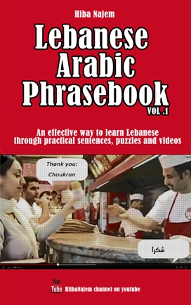

“Lebanese Arabic Phrasebook Vol. 1” was published on Amazon on the 24th of July 2014 as an eBook, and then on the 12th of October as a paperback book.
This book was the result of 4 years of teaching the Lebanese Arabic dialect on YouTube, on the most successful Lebanese teaching channel in terms of views, subscribers and ratings: Learn Lebanese Arabic with Hiba Najem.

Description
A very practical way to learn Lebanese
This is a Lebanese Arabic phrasebook, in a sense that it is designed to both:
1- Give you all you need to know to get by speaking Lebanese when travelling to Lebanon
2- Offer you a very practical and easy way of learning the dialect
Method found to be very efficient by students
The method and phrases used in this book have been developing since 2011 through Hiba’s teachings of the Lebanese dialect through video lessons on YouTube, as well as private lessons on Skype.
They have been tweaked and are constantly evolving through the feedback of the students, focusing on what they find to be useful and efficient.
Every phrase is linked to a video so you could perfect the pronunciation.
The most important aspect of learning a new language is to hear it being spoken by natives. Especially since Lebanese is considered as "spoken Arabic".
That is why the advantage of this book is that EVERY word and sentence used, is linked to the video in which it was taught, so you can hear it, and try to master the pronunciation. And unlike books with audio CDs, in this case the videos are always available online and you could easily access them on your phone, tablet or computer anywhere you are.
Translation and Transliteration
Each English phrase is translated to Lebanese using the Arabic alphabet for those who are Arabic literate, and then in its turn transliterated to the Latin alphabet for those who aren't.
Exercises and Puzzles
In order to help you master the material, there are exercises and puzzle at the end of the book, such as crosswords and word search.
Chapters
There are seven chapters in this book. The first six define categories of the phrases taught throughout the chapters, while the last one is dedicated for language exercises and puzzles.
The first chapter entitled “Basic Language” Contains five subcategories: Numbers, Colors, Days, Pronouns and Prepositions.
The second chapter, “Travelling”, offers sentences that you will need if you are travelling to Lebanon and the subcategories are arranged by what you might chronologically use: Airport, Directions, Money, Accommodation and Shopping.
The third, fourth and fifth chapters will contain everyday sentences as well as phrases to use around friends, family and in relationships and conjugations of few verbs in the Lebanese Arabic dialect.
The sixth is the last chapter containing phrases. It will have a variation of random sentences, uncategorized, which we have been asked to teach by viewers of the videos or which we have found to be practical and fun to be learnt.
The final chapter will consist of “fill in the blank” exercises, as well as crosswords and word search puzzles.

Author bio
Hiba Najem, has been teaching Lebanese Arabic online since 2011, and has fixed her method according to her students' needs and feedback. The social aspect of online teaching has helped her in developing her teaching into a very effective style.

Comparative analysis
The below titles are those similar to ours, available on the market:
- Nitzany, Y., Conversational Arabic Quick and Easy: the most advanced revolutionary technique to learn lebanese arabic dialect! (Lebanese Dialect), CreateSpace Independent Publishing Platform, 2014, 978-1500125653, 44 pages, $12.99, # 253,870 in Books on Amazon.com, 4.4 out of 5 stars (18 customer reviews).

This book is the most similar in method to our book. It doesn’t profess to teach the Lebanese dialect in a structured and academic way, but instead it offers words and sentences that would help people understand the dialect, and be understood while speaking it.
The differences, though, are the following:
1- The words and sentences in this book are written in English Transliteration, while in our book, they are written in both English transliteration and in the Arabic alphabet according to the requests of many of our YouTube audience who are familiar with the Arabic alphabet, and find it more accurate to learn in Arabic letters.
2- In addition to the written book, we also offer links to the YouTube videos which adds an easily accessible audio feature to the learning experience.
3- The last chapter of our book offers games and puzzles to help the readers master the material.

- Kassab, M., 701 Lebanese Verbs: conjugated in the new and easy to read Lebanese Latin Letters, Black Pinnacle LLC, 2013, 978-0615751245, 112 pages, $19.99, # 235,720 in Books on Amazon.com, 3.9 out of 5 stars (9 customer reviews).

This book seems to be an extensive collection of Lebanese verbs and conjugation, which customers also find useful as a large part of the verbs is also used in different Arabic dialects. Being a verb conjugation book, the taught words are evidently out of context, which seems to bother some of the customers according to their reviews.
There also is trouble with the transliteration, as the English transliteration used in this book doesn’t seem to have any valid ground. For example the Arabic letter “ع” is transliterated into the letter “x”, which might be confusing since the letter “x” in the Latin alphabet is pronounced differently from the letter “ع”.

- El-Hage, G. N., marHaba: A Course in Levantine Arabic - Lebanese Dialect, CreateSpace Independent Publishing Platform, 2015, 978-1508595311, 246 pages, $15.00, # 163,906 in Books on Amazon.com, 3.8 out of 5 stars (4 customer reviews).

This book is a combination between a phrasebook and a course book. Like our book, it is divided into chapters by topic, the text is written in both Arabic letters and transliteration, and there are exercises to help the student learn the material. Since it is not only a phrasebook, it provides some grammatical concepts.
But even though the book is designed for students to work on their own, it fails to provide audio for the students to know how things are pronounced and spoken.

- Feghali, M. N., Spoken Lebanese, John F. Blair Publisher, 2003, 978-1887905145, 232 pages, $27.13, # 297,243 in Books on Amazon.com, 3.3 out of 5 stars (16 customer reviews)

This is one of the oldest books on the Lebanese dialect in the market. The author teaches the dialect through a phonetic system he developed. This system is based only on transliteration and thus the words are not written in the Arabic script.
It teaches Lebanese through scenarios and dialogues, however, reviewers have found that the absence of any audio reference renders the learning more difficult.

- Haydar, A., Haydar P., Sinno, N., Haki bil-Libnani Access Code: Lebanese Arabic Online Textbook and Companion Website to Al-kitaab Part One, Georgetown Univ Pr, 2014, 978-1626161542, number of pages unknown, $23.30, # 1,796,096 in Books on Amazon.com, No star rating.

This book is part of the “Al-Kitaab Texbook”, a fully online textbook that teaches the Arabic language. The Haki bil-Libnani book is a retake of the Arabic textbook in a Lebanese context. The readers learn the dialect through a storyline of different Lebanese characters living their daily life in Lebanon.
Also, it is recommended to have access to the website where there are videos that help you benefit as much as possible from the course.

- Chouairi, R., Alosh, M., Shou fi ma fi?: Intermediate Levantine Arabic, Yale University Press, 2010, 978-0300153910, 240 pages, $51.55, # 780,700 in Books on Amazon.com, 3.9 out of 5 stars (12 customer reviews).

This book teaches Levantine Arabic, meaning the dialects spoken in “Syria, Lebanon, the Holy Land, and western Jordan”. According to the book’s description, it is recommended to have knowledge in MSA before reading this book.
It also provides access to a website with audio references to the taught material.
Reviewers have found the audio provided to be angry, and some have said that the language used could be considered abusive.

- Haddad-Fadel, H., Lebanese dialect and literal arabic, Haddad-Fadel, 2008, 978-0000104007, 220 pages, $34.00, No Sales Ranking, No star rating.

- Giappesi, J., Lebneini w 2aktar: A Lebanese Arabic Method, Dar Manhal el Hayat, 2012, 978-9953530512, 133 pages, $24.00, No Sales Ranking, No star rating.

In review of all the available titles on the subject, customers seem to have two main issues:
- The sentences being only transliterated and not written in the Arabic script.
- No audio available to help the readers in the pronunciation of the words and sentences.
Our book covers these issues, with a plus of having additional video references to help explain the sentences further, and also having exercises to help them practice what they learnt.
Based on these features, our book has received the following review ratings:
- Amazon.com: 4.5 out of 5 stars
- Amazon.co.uk: 5 out of 5 stars
- Goodreads: 4.75 out of 5 stars

Market
According to the audience engagement on the YouTube channel, the Facebook page and the students of our one-on-one Skype lessons, the people interested in learning the dialect are:
- Foreigners living in Lebanon, either for a short or a long term. It could be distributed to hotels, coffee shops or embassies. Tourist arrivals to Lebanon in 2014 (source below):
  - Europe: 447,668
  - America: 224,621
  - Asia: 113,597
  - Africa: 55,613
  - Oceania: 50,883
  - Others: 1,443
- Lebanese descendants living abroad. The estimated Lebanese population in the main English speaking countries:
  - United States: 506,400 Born in Lebanon (about 3 million from Lebanese descent)
  - Australia: 271,000
  - Canada: 190,275
  - New Zealand: 45,300
- People in a relationship with someone Lebanese.
- Other Arabs looking to learn the different Arabic dialects:
  - Arab Tourist arrivals in 2014: 460,822
- Polyglots around the world.
Tourist arrivals to Lebanon by region (Jan-May 2015):
(source: BankMed http://www.bankmed.com.lb/LinkClick.aspx?fileticket=1JdTgPxyyQM%3D&portalid=0 )
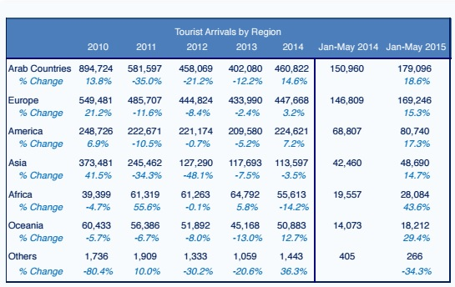
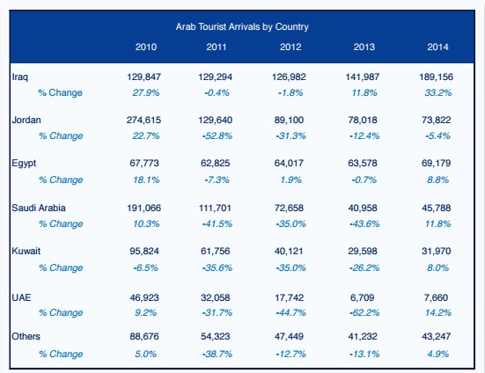

The YouTube channel so far has 4,913 subscribers, with about 17,000 views per month. Around 3,300 of these monthly viewers are located in Lebanon.
28% of fans on our Lebanese Arabic facebook page are from Lebanon, 60% of these being from Beirut.
Be it our channel, or our blog, they are ranked in the top 10 Google results for the main keywords in our niche, often occupying more than one first page:
- Lebanese Arabic
- Learn Lebanese
- Learn Lebanese Arabic
- Learn Lebanese lesson
- Lebanese dialect
- Learning Lebanese Arabic
- Learn Arabic Lebanese
- How to speak Lebanese
- Lebanese lessons
- How to speak Lebanese Arabic
- Lebanese language
- Learn Lebanese dialect
The book is also referenced on the following sites:
- University of Oxford Library Catalogue: http://solo.bodleian.ox.ac.uk/OXVU1:oxfaleph019991332
- Omniglot: The online encyclopedia of writing systems and languages: (17,700 Alexa rank)
http://www.omniglot.com/books/language/arabic.htm

Books sold
So far, the book has been available as an eBook and a paperback, only on Amazon. eBook sales on Amazon are restricted to countries in which an Amazon site is based. The ebook sales rank on Amazon.com is #59 in the “Phrasebooks” category in the Kindle store
Many customers have contacted us in order to purchase the paperback book, especially those living in Lebanon and Arab countries, since shipping fees are high when purchasing from Amazon. The paperback sales rank on Amazon.com is #99,952 in “Books”, and #71 in the “Phrasebooks” category.
(“Sales rank” on Amazon is updated on an hourly basis. All ranks in this document are as of 00:00 11/4/15).

